Master
Installation of master server and configuring
1 sudo apt-get update &&
2 sudo apt-get install openjdk-8-jdk –y &&
3 wget -q -O - https://pkg.jenkins.io/debian-stable/jenkins.io.key | sudo apt-key add - &&
4 sudo sh -c 'echo deb https://pkg.jenkins.io/debian-stable binary/ > \
5 /etc/apt/sources.list.d/jenkins.list'
6 sudo apt-get update &&
7 sudo apt-get install jenkins –y &&
8 sudo ssh-keygen

9 ls
10 cd .ssh
11 ls
12 cd ..
15 sudo apt-get update
16 service jenkins status
17 java -version
18 sudo apt-get update
Git :- here getting the source from git hub and pulling the Docker file from Github
84 mkdir final
85 cd final
86 pwd
87 cd /home/ubuntu/final
88 cd ..
89 git clone https://github.com/hshar/website.git
90 ls
91 rm 1.html
92 ls
93 rm ex
94 rm -r ex
95 ls
96 cd final
97 cd ..
98 cd website
99 ls
100 cp -r ./ /home/ubuntu/final/
101 cd ..
102 cd final
103 ls
104 clear
105 git init
106 git remote add origin https://github.com/vin0139/final.git
107 git remote add origin https://github.com/vin0139/www.git
108 git remote add origin https://github.com/vin0139/vin01399.git
109 git remote add origin https://github.com/vin0139/16_9_2021vin.git
110 git remote set-url origin https://github.com/vin0139/16_9_2021vin.git
111 ls
Creating Docker file and getting source from github
112 sudo nano Dockerfile
113 ls
114 git status
115 git add .
116 git commit -m "docker file created"
117 git status
Managing Git Branching
118 git branch develop
119 git branch
120 git push origin master
121 ls
122 git checkout develop
123 git add .
124 git commit -m "develop"
125 git push origin develop
126 history

Creating Test -server

1 sudo apt-get update
2 sudo apt-get install openjdk-8-jdk -y
3 sudo apt-get update
4 ls
5 cd jenkins/
6 ls
7 cd workspace/
8 ls
9 cd build_job/
10 pwd
11 ls
12 cd cap_10_sep
13 ls
14 ls -l
15 sudo apt-get install docker.io -y
16 cd ..
17 sudo apt-get install docker.io -y
18 ls
19 cd cap_10_sep/
20 ls
25 cd ..
26 ls
27 cd jenkins
28 ls
29 cd workspace/
30 ls
31 cd build
32 cd build-job
33 ls
34 pwd
35 docker file
36 docke --help
37 docker ps
38 sudo docker images
39 history
ubuntu@ip-172-31-12-241:~/jenkins/workspace/build-job$

Creating production-server
1 sudo apt-get update
2 cd .ss
3 cd .ssh
4 ls
5 sudo nano authorized_keys
6 sudo su
7 sudo nano authorized_keys
8 sudo apt-get update
9 clear
10 cd jenkins
11 cd workspace/
12 cd production/
13 ls
14 pwd
15 sudo apt-get install docker.io -y
16 sudo docker images
17 sudo docker ps
Creation of Master, Test, Production Nodes

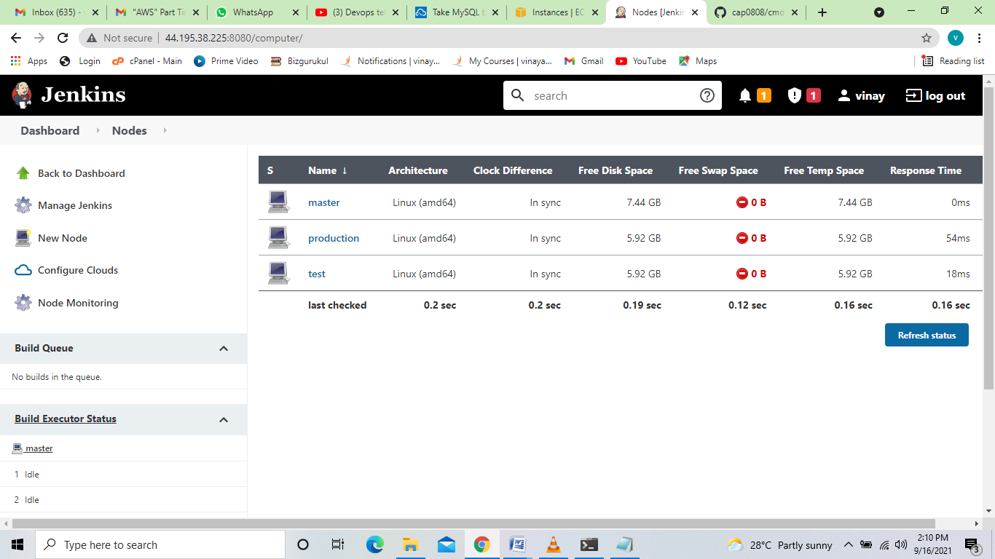

Running test job
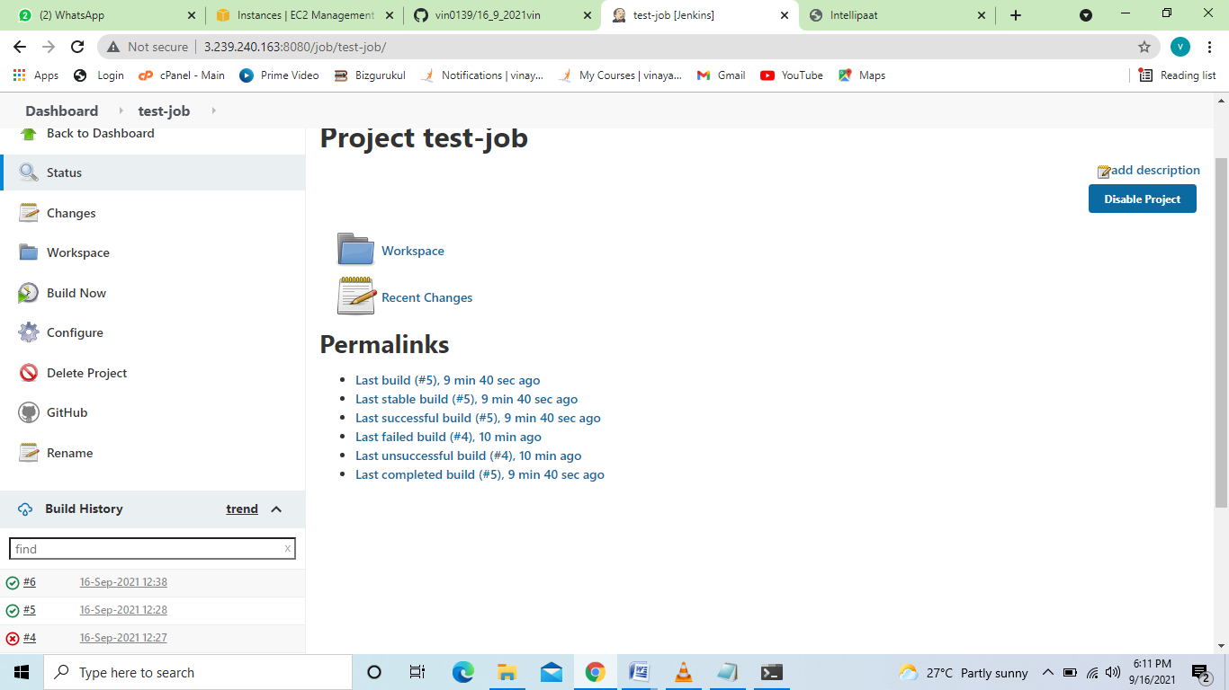

Console OutPut
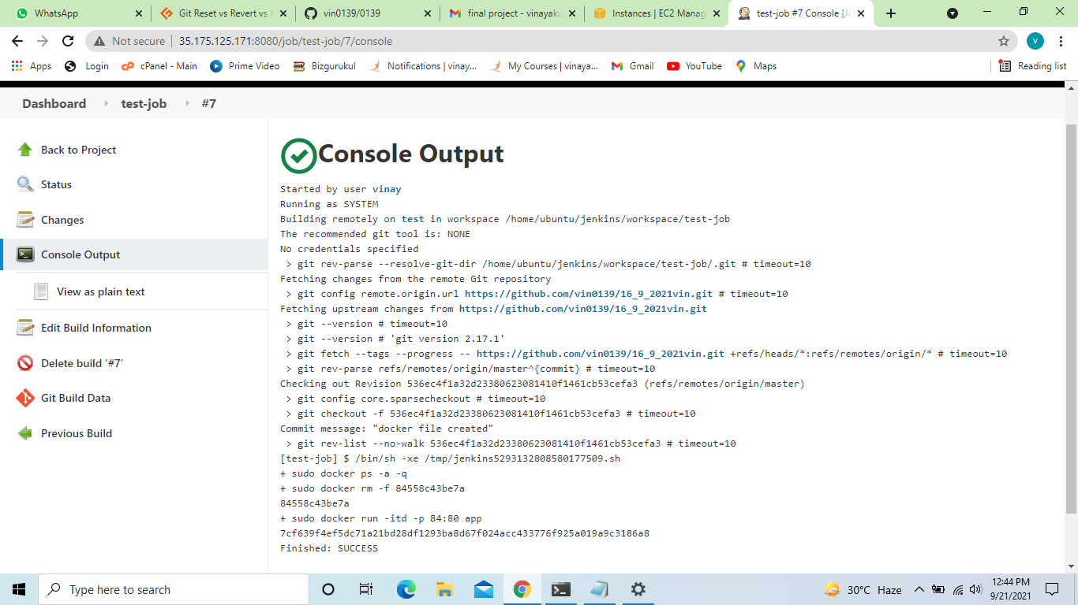

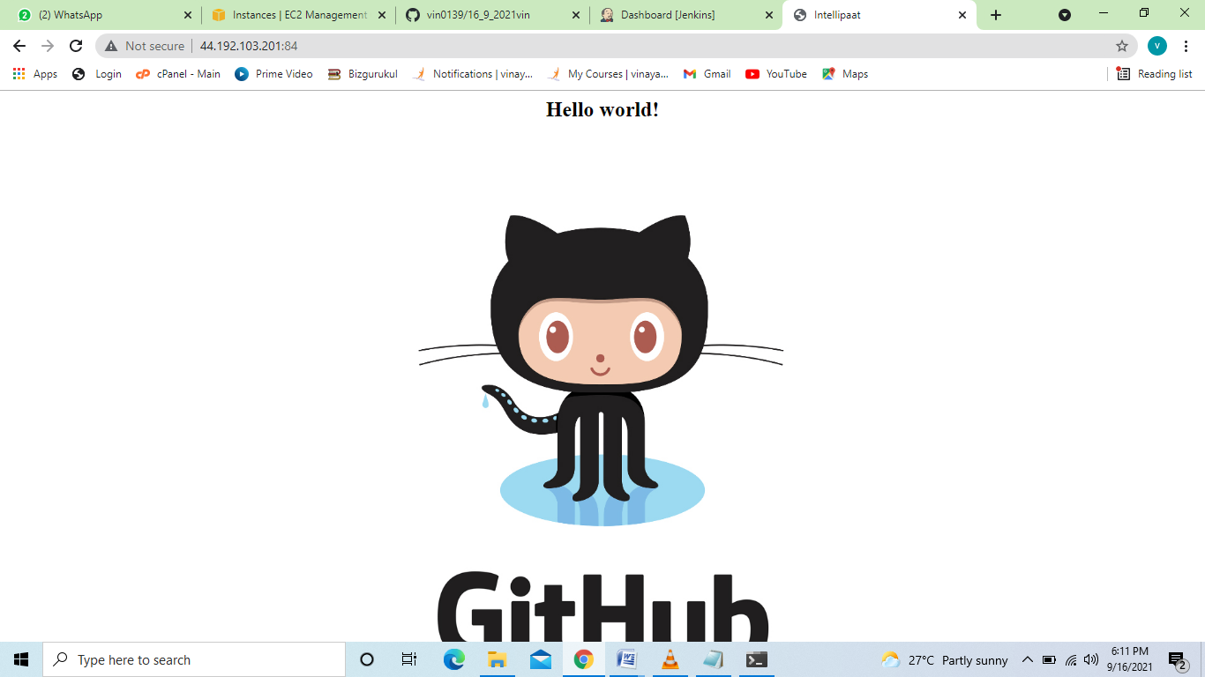
Running build- job
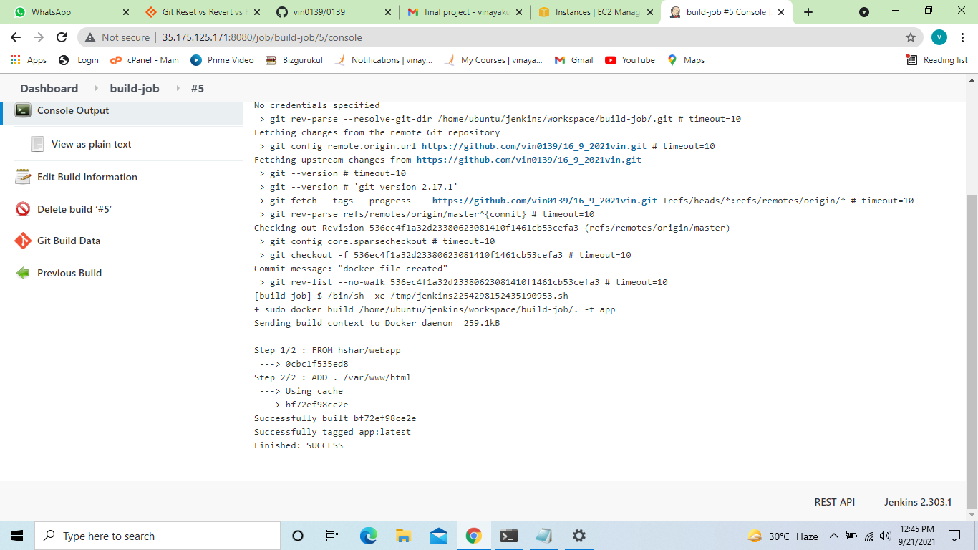

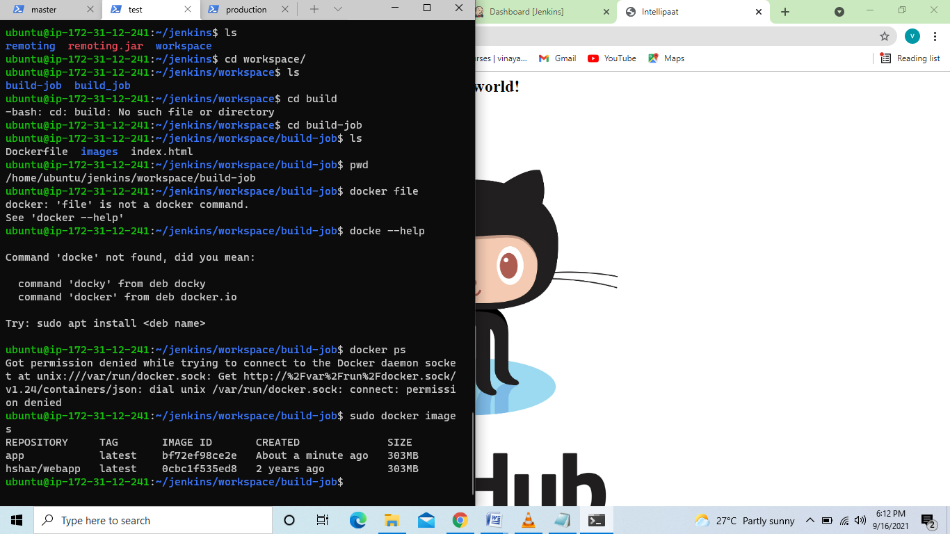

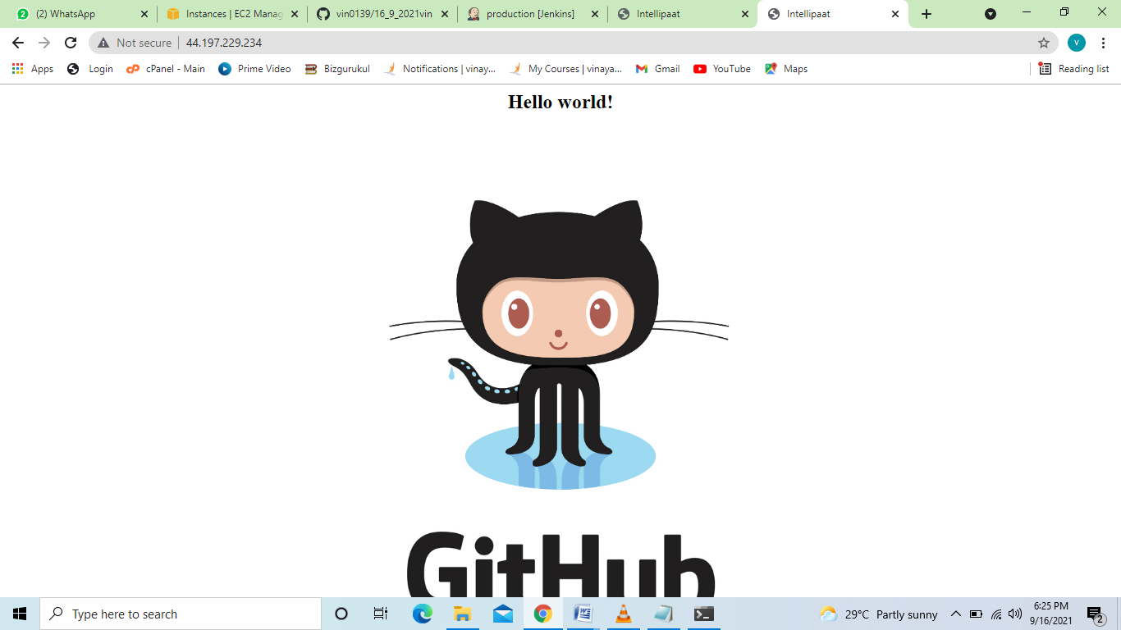

Running –Production job
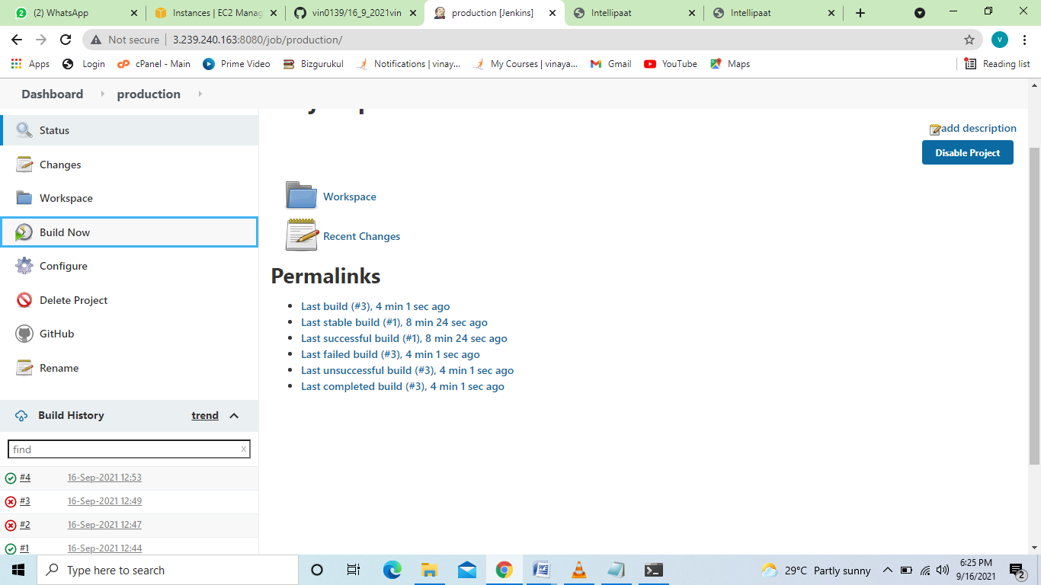
Running Production job

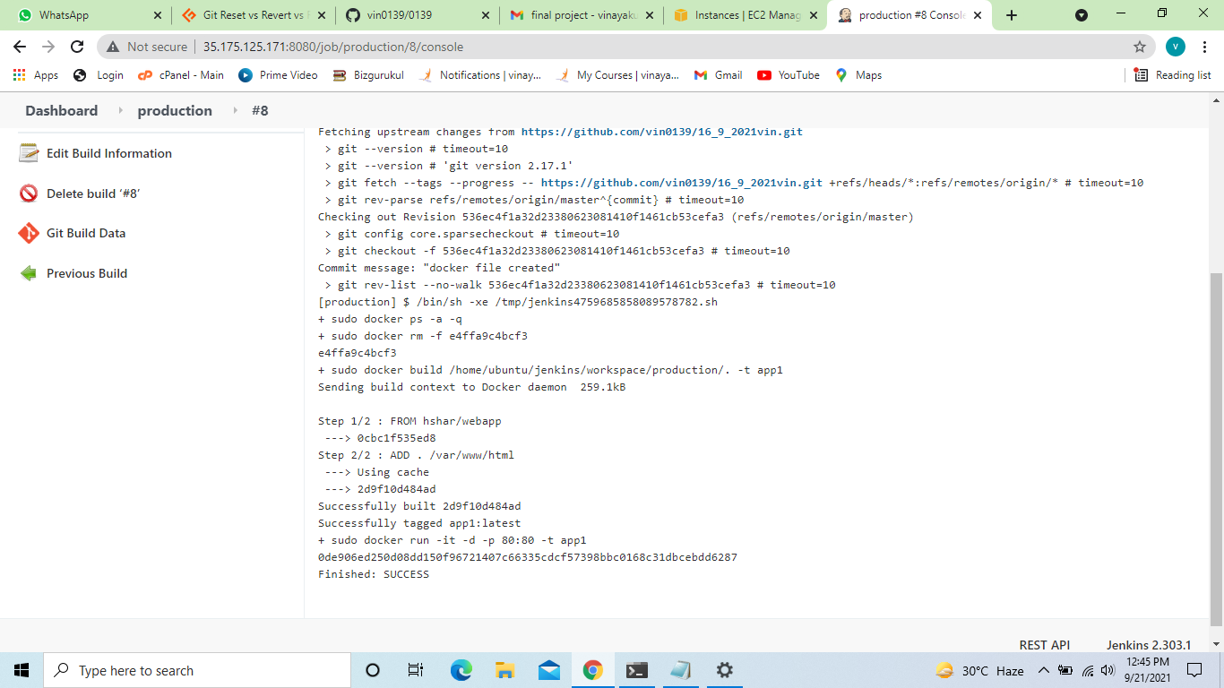

Out Put-

